Daniel Fryer
Assignment 1.2 Git Setup
8/14/2026

Git Photo:
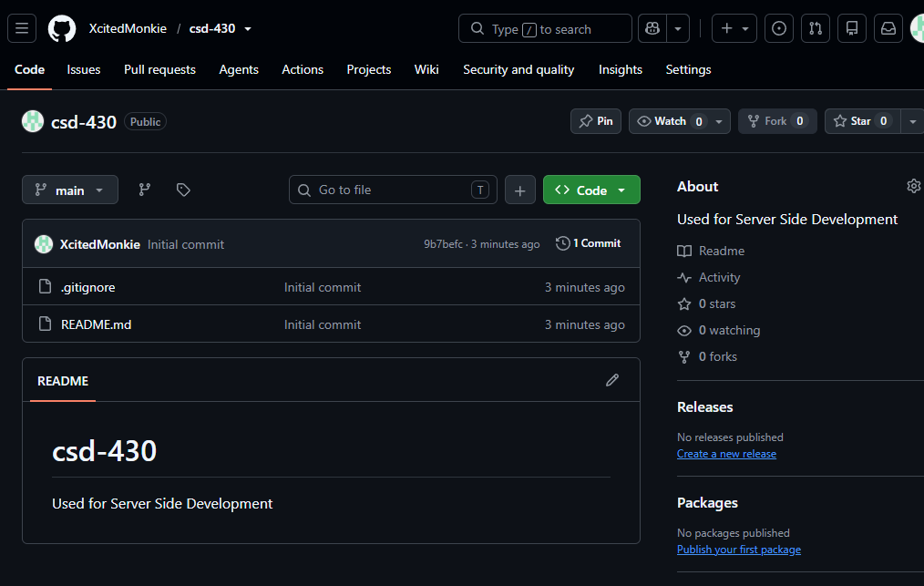

Local setup:
